- Create VPC with 2 private and 2 public subnets.
Step 1: Login to your AWS console, select VPC Create VPC Enter details Create VPC.
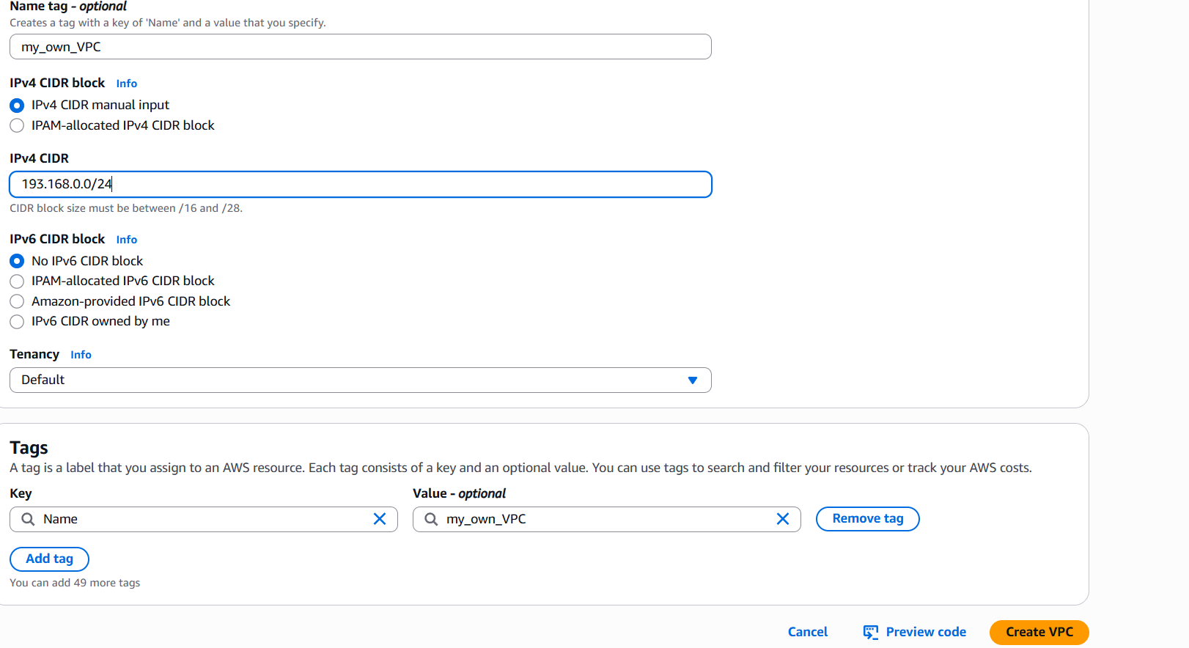
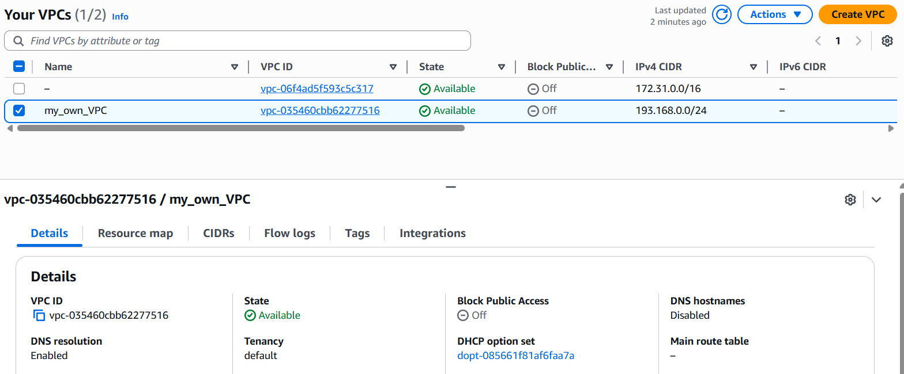
Step 2: Select subnet create subnet Enter details, repeat the same to create 2 public and 2 private subnet.
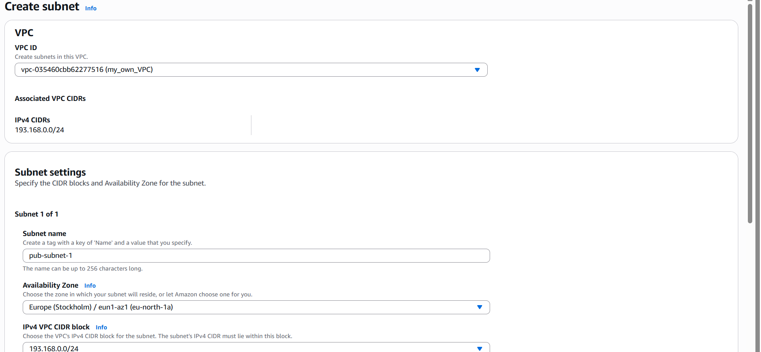

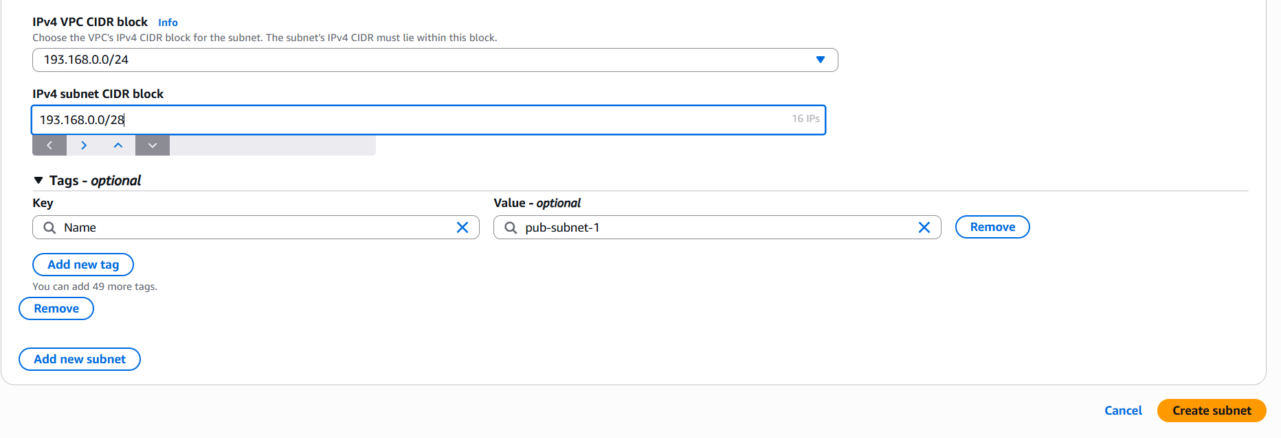
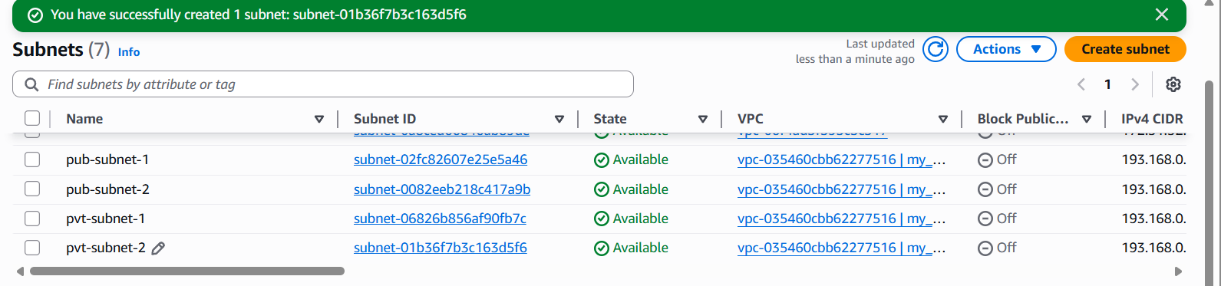

- Enable DNS Hostname in VPC.
Step 1: Login to Aws console select VPC your VPC Actions Edit VPC settings.
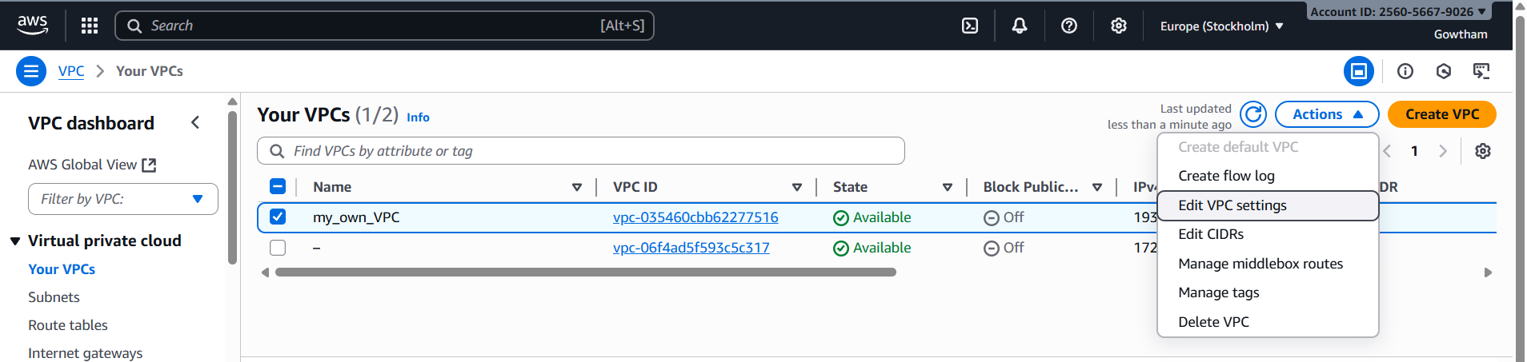
Step 2: Select Enable DNS hostnames under DNS settings and save.
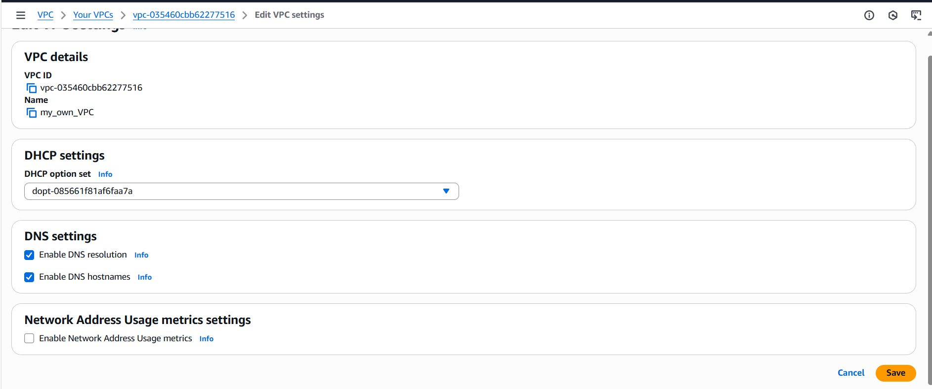

- Enable Auto Assign Public IP in 2 public subnets.
Step 1: Login to AWS console select VPC subnets Actions Edit subnet settings
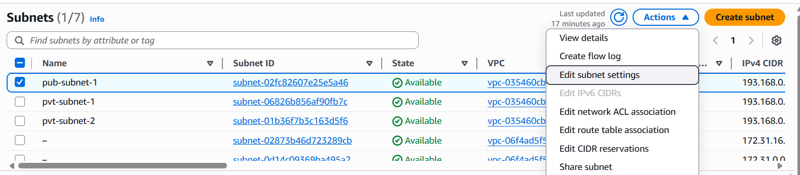
Step 2: Select Enable auto-assign and save. Repeat the same for 2nd subnet.
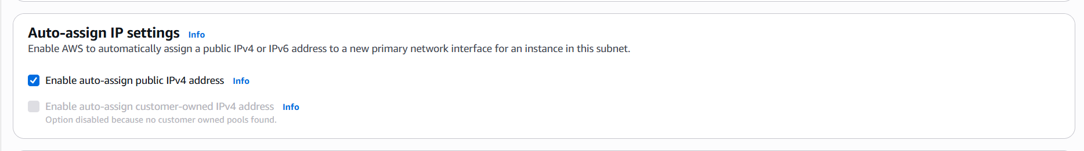
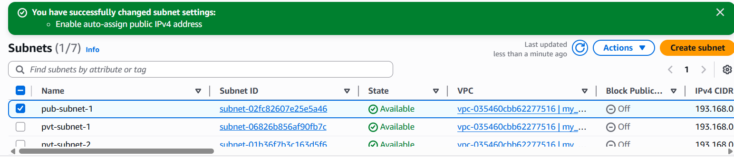

- Add 2 private subnets in private route table.
Step 1: Login to AWS select VPCRoute tableCreate RTEnter detailsCreate Route table.
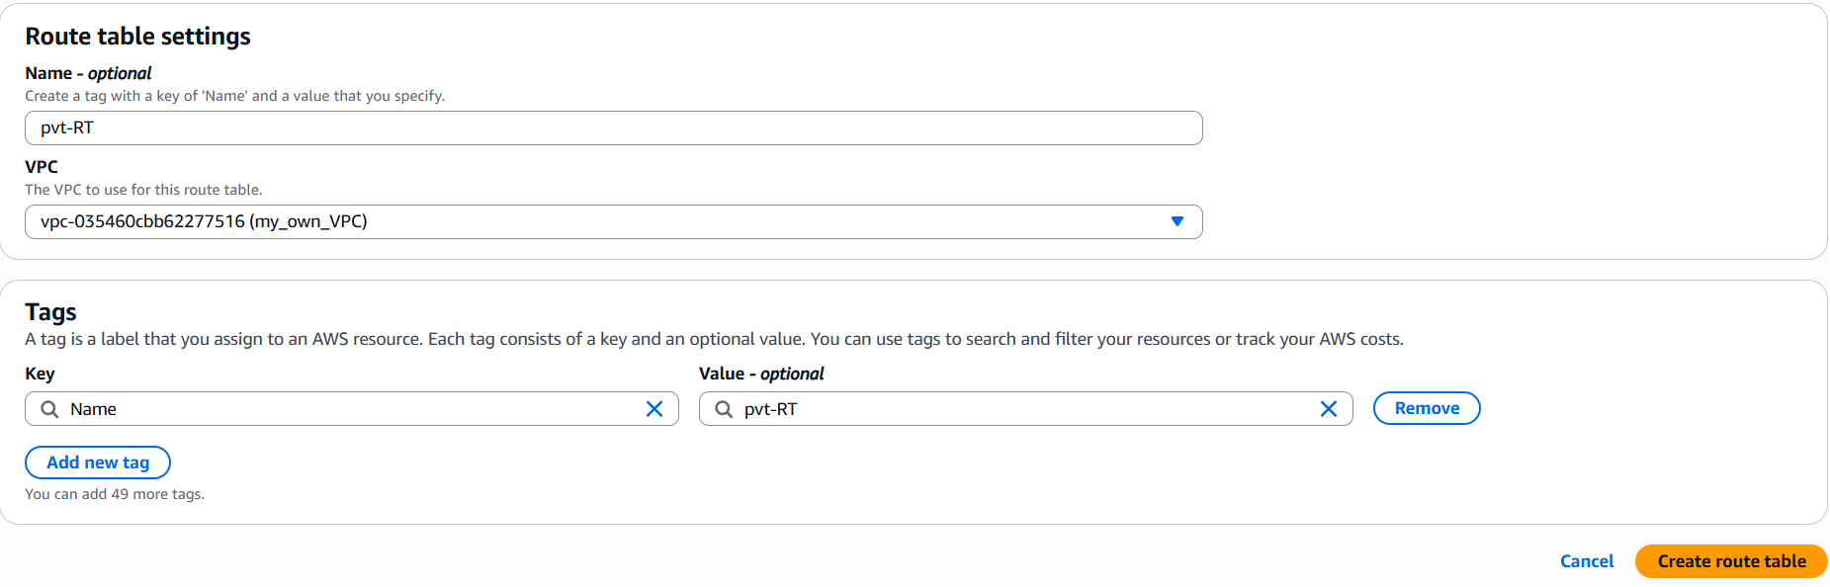
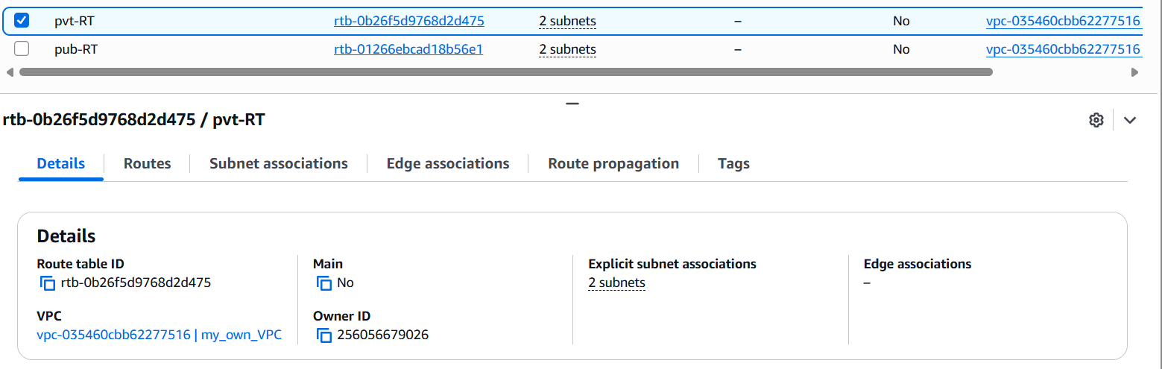

Step 2: select Subnet association Edit SA select private subnet Save.
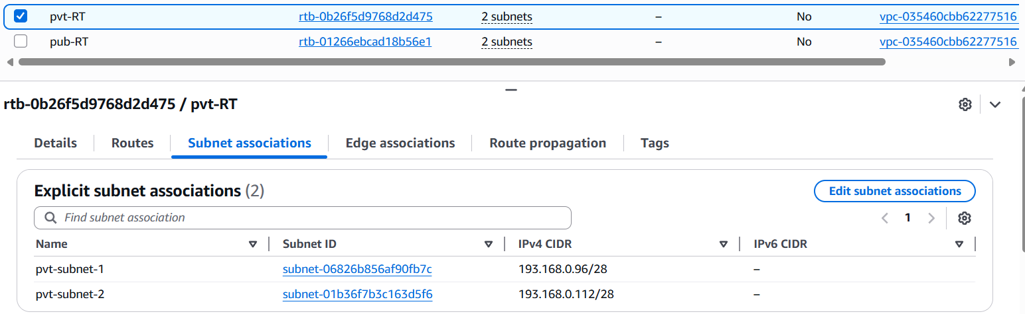

- Add 2 public subnets in public route table.
Step 1:Login to AWS console select VPCRoute tableCreate RTEnter detailsCreate Route table.
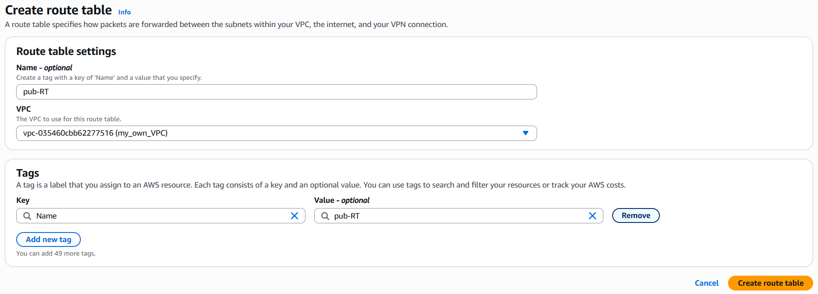

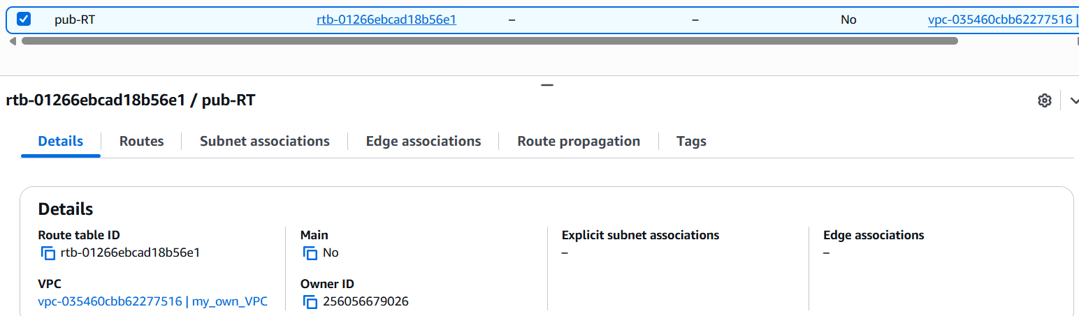
Step 2: select Subnet association Edit SA select public subnet Save.
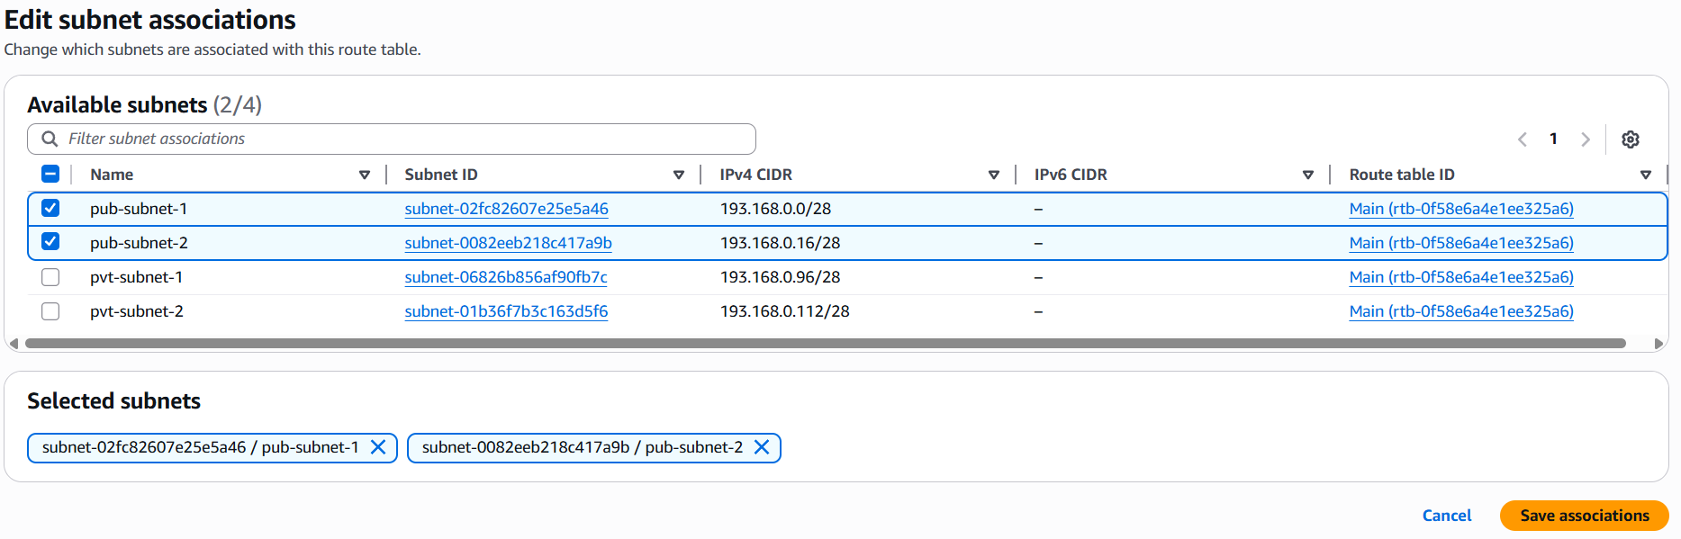
- Public route table will have the routes to internet and local.
Step 1: Login to AWS console and select Internet gateways create internet gateway enter details create IGW.
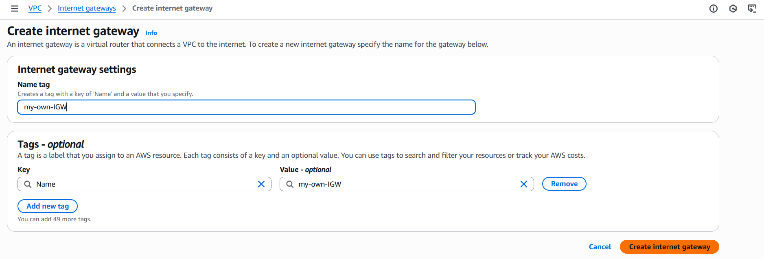
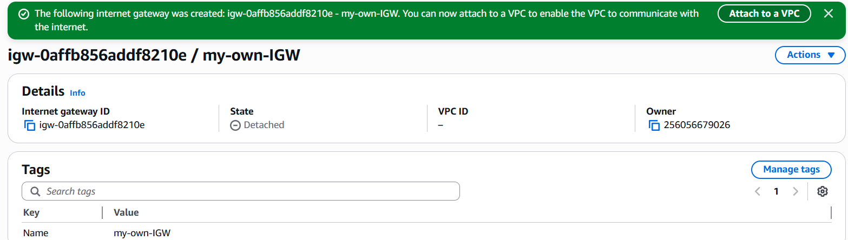
Step 2: Select Attach to VPC Your VPC Attach IGW.
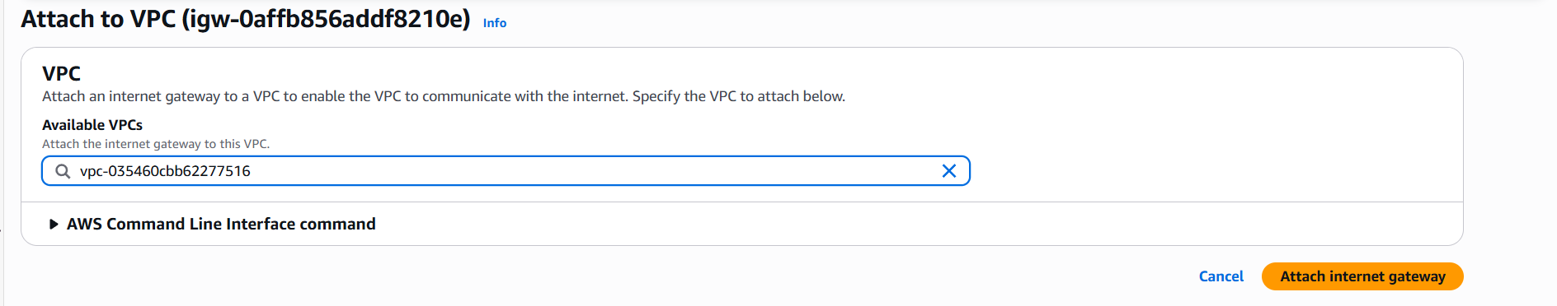
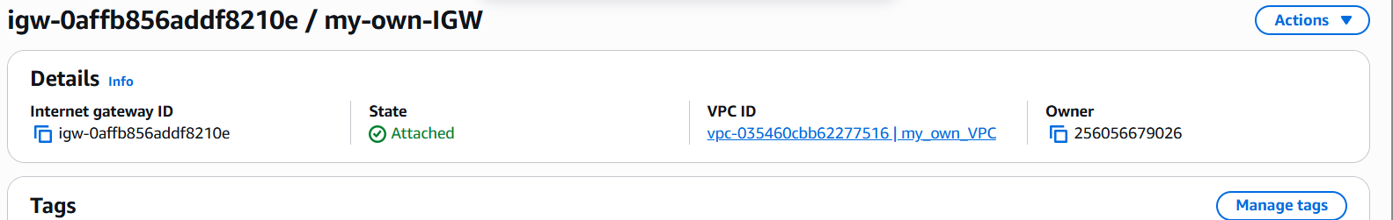
Step 3:Select RouteEdit routeAdd routeselect your IGW to grant internet access to public subnet.
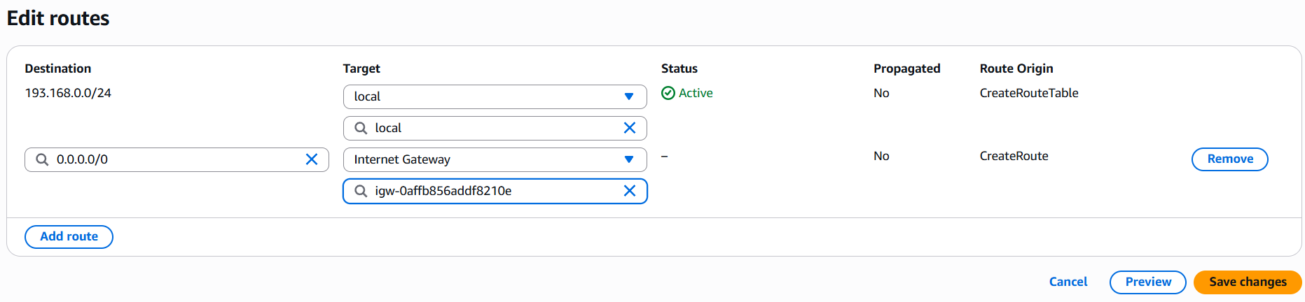
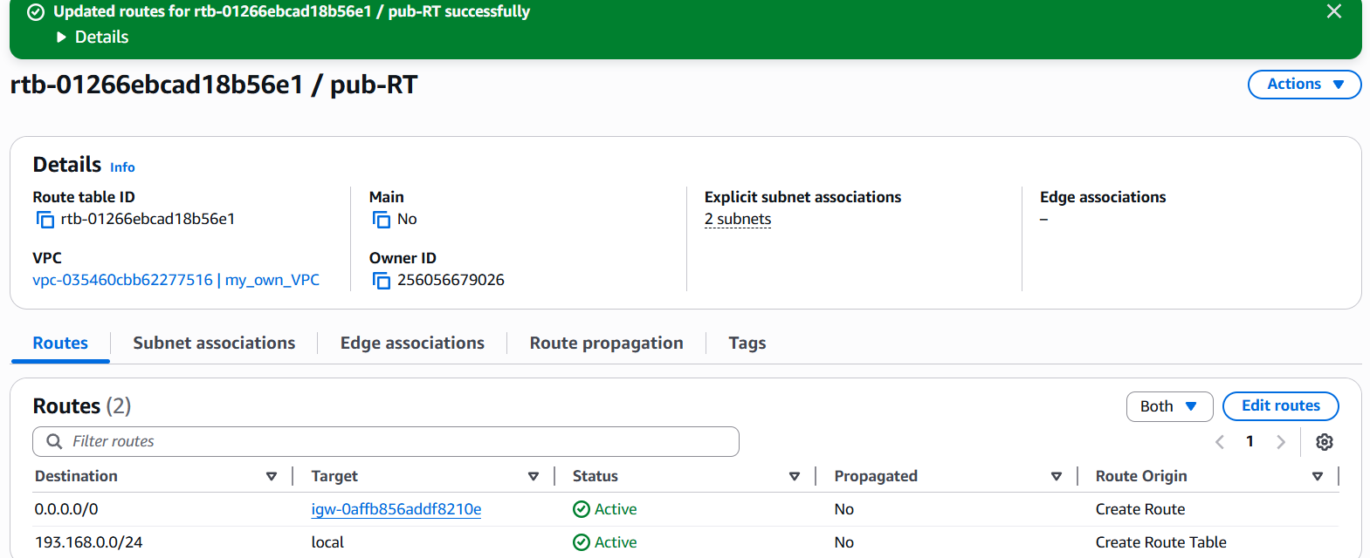

- Create EC2 in public subnet with t2.micro and install PHP.
Step 1:Login to AWS console select EC2Launch EC2select required configurations.
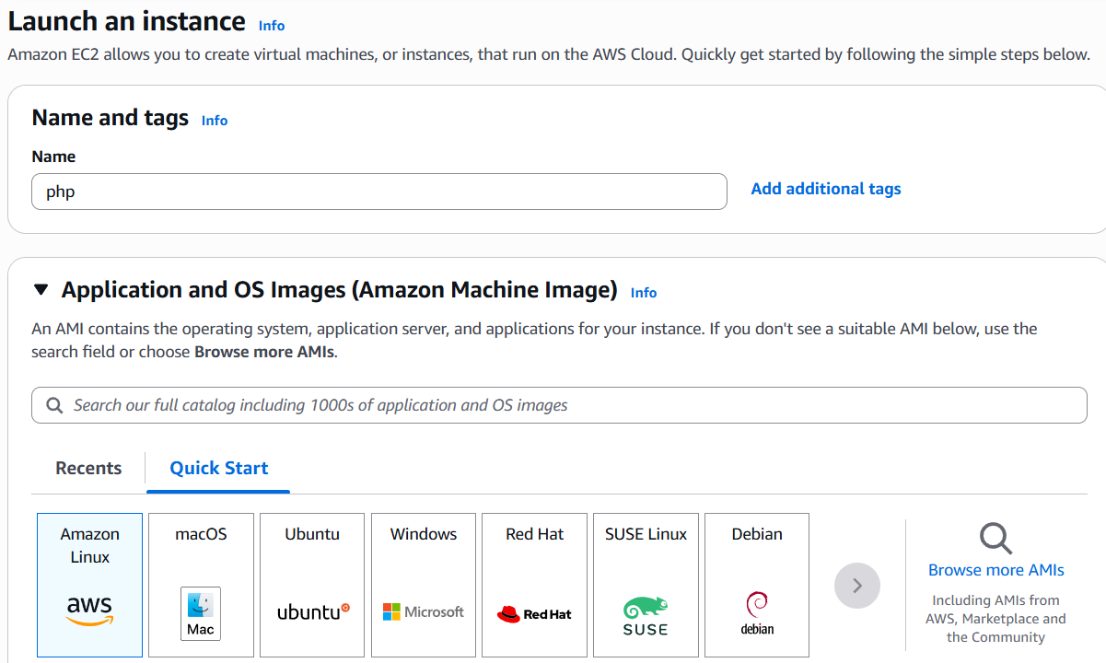
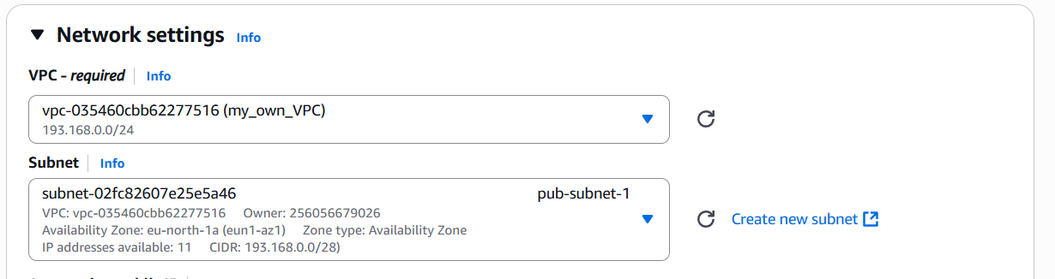

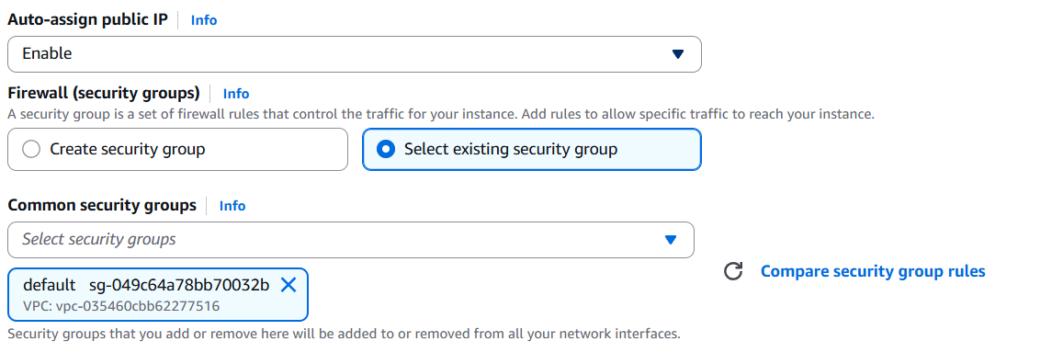
Step 2: In User data enter script to install httpd and php and click launch instance.
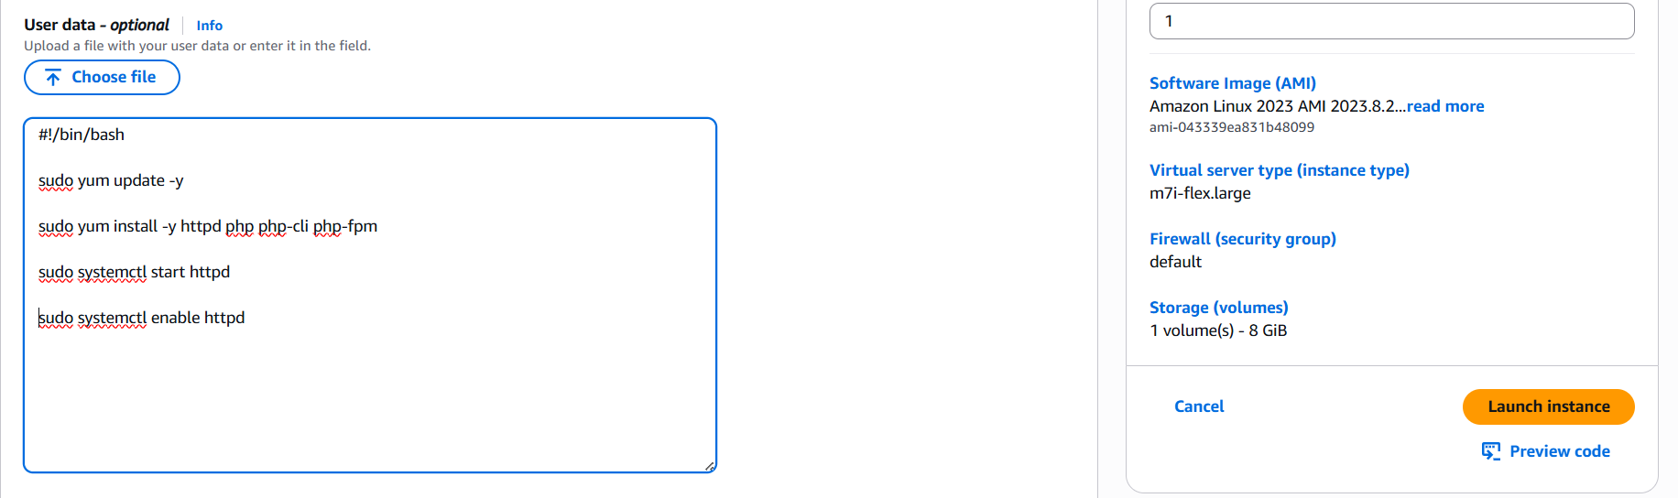
Step 3: Change the inbound rule to allow SSH, HTTP, HTTPS ports.
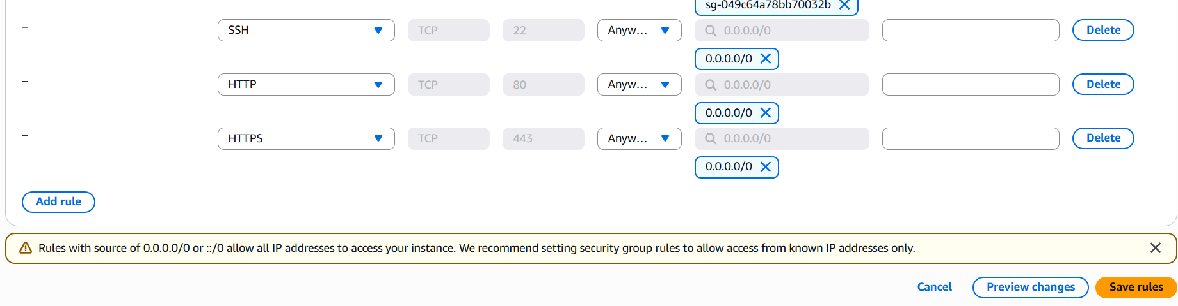
Step 4: copy the public of instance and run public_ip/phpinfo.php in your browser.
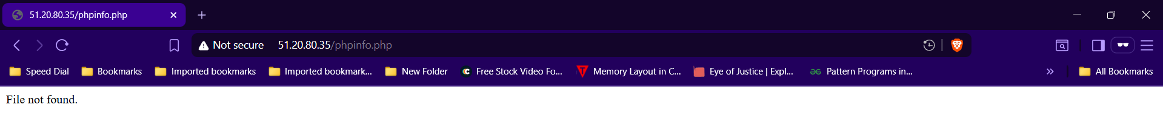

- Configure NAT gateway in public subnet and connect to private instance.
Step 1: Launch an instance in public subnet.
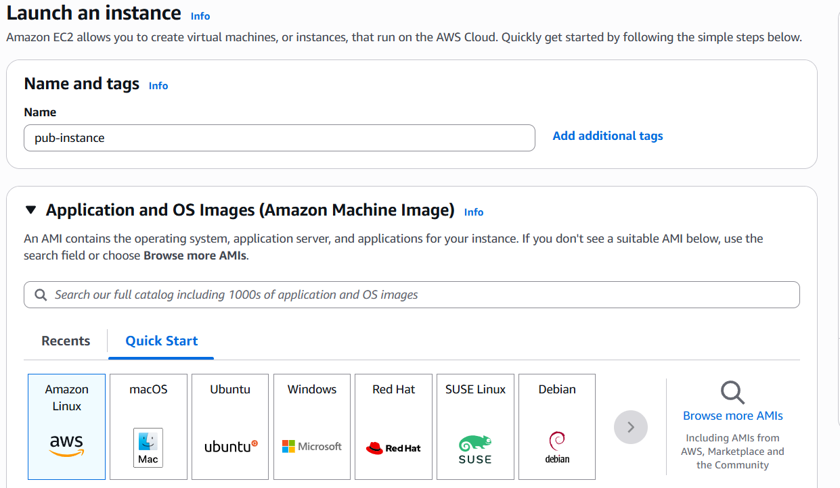
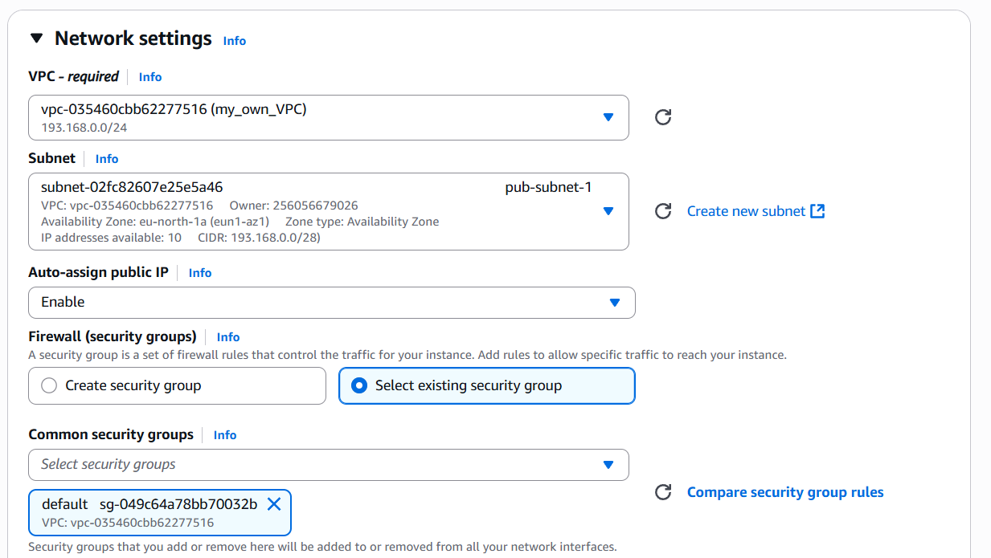
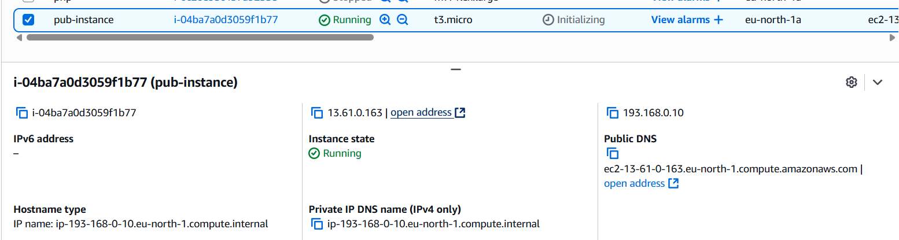
Step 2: Launch an instance in private subnet.
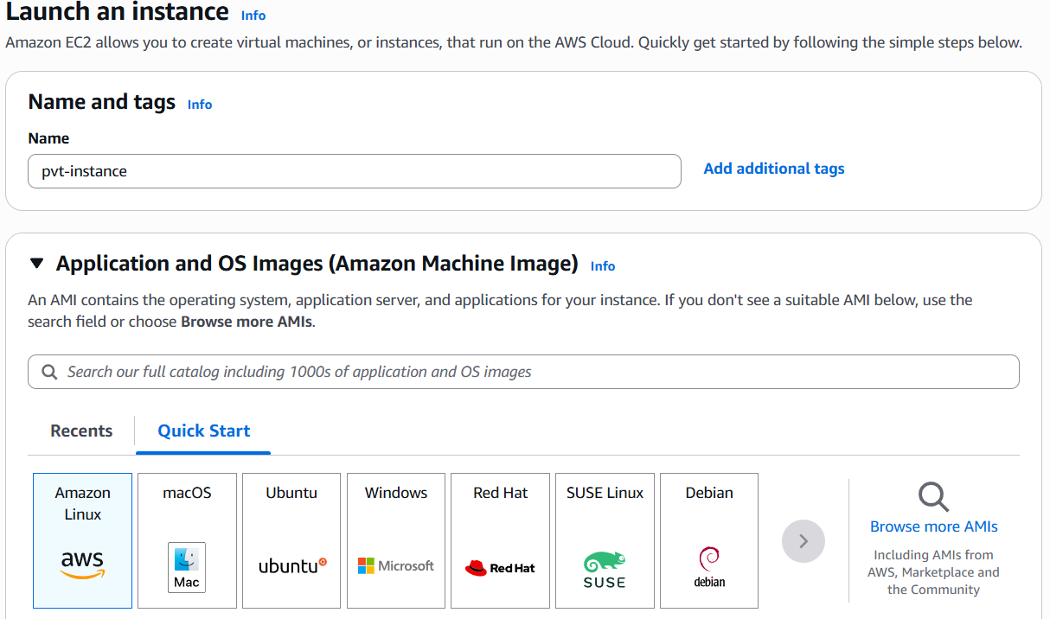
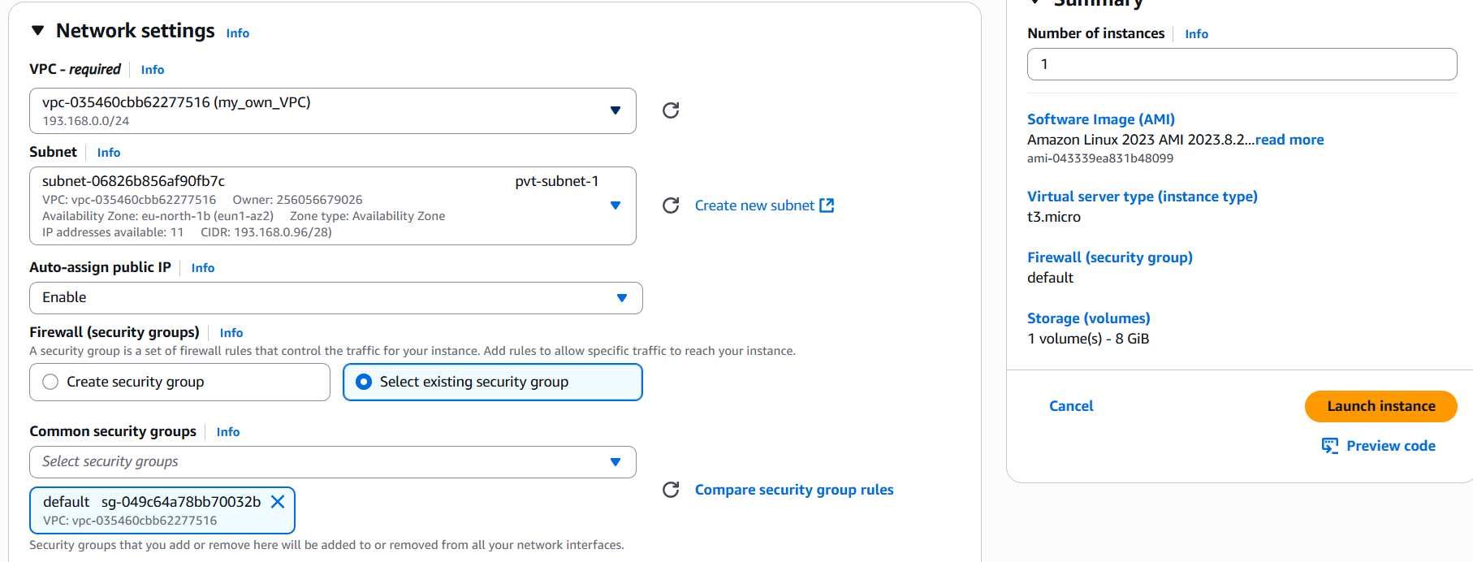
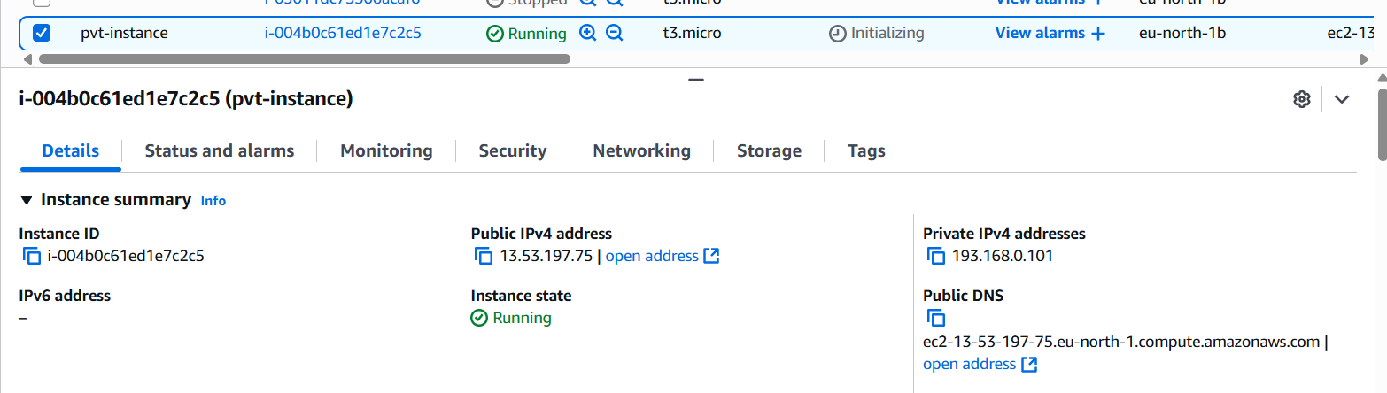
Step 3: Copy the security_key.pem and paste it in new .pem file in your public instance.
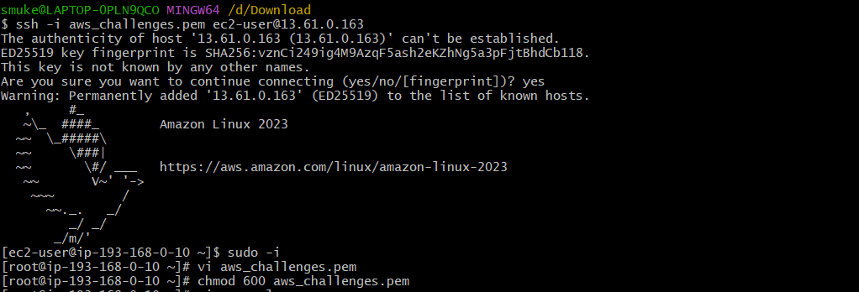

Step 4: Use ssh -I security_key.pem user_name@private_ip_of_pvt-instance to connect to private instance and use ping URL to check for network connectivity.
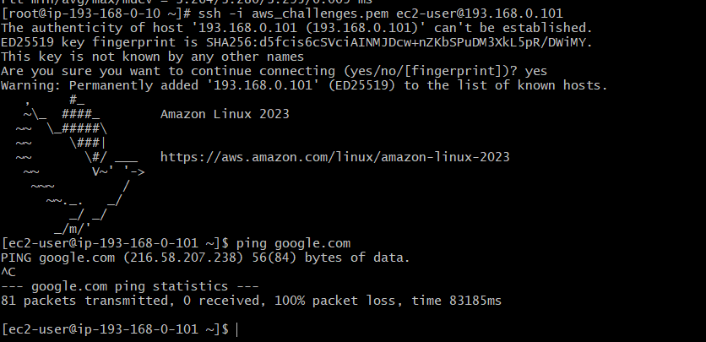
Step 5: In AWS console goto NAT gatewayscreate NAT gatewayEnter details.
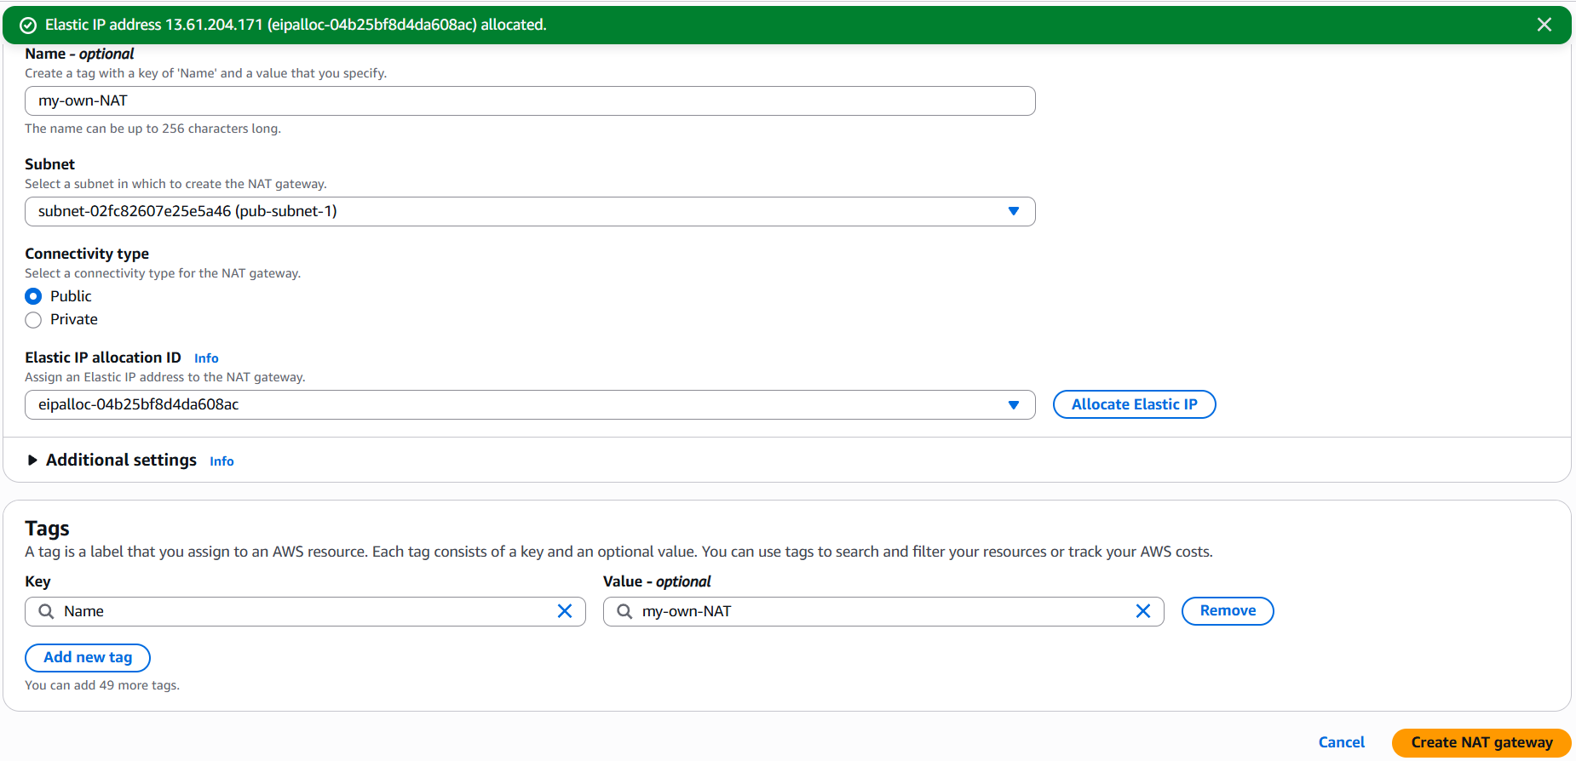
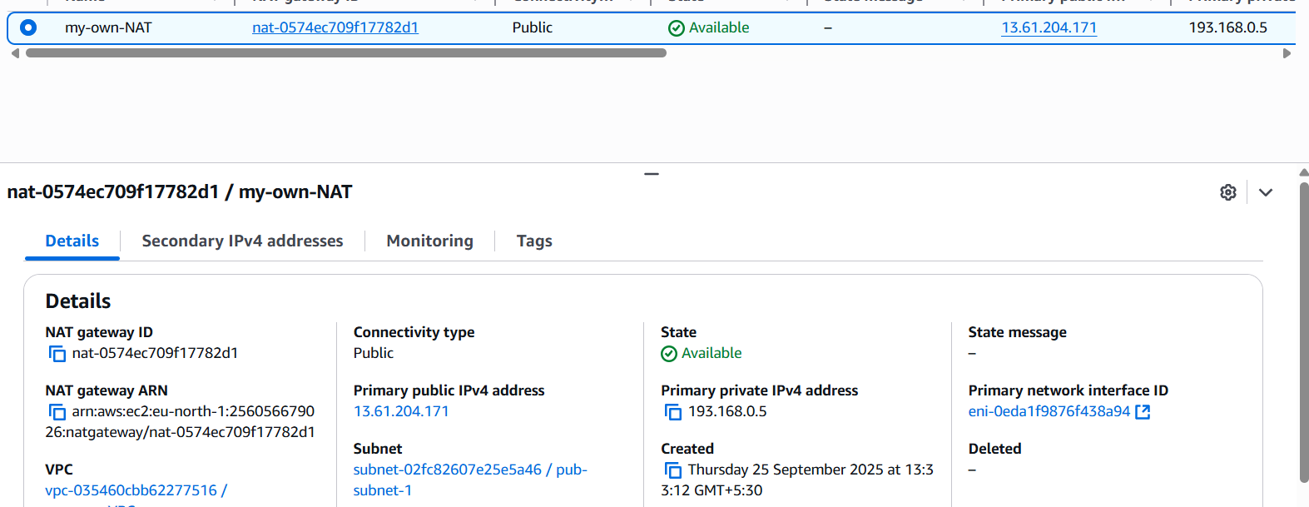
Step 6: Goto Route tableselect private RTRoutesEdit Routes.
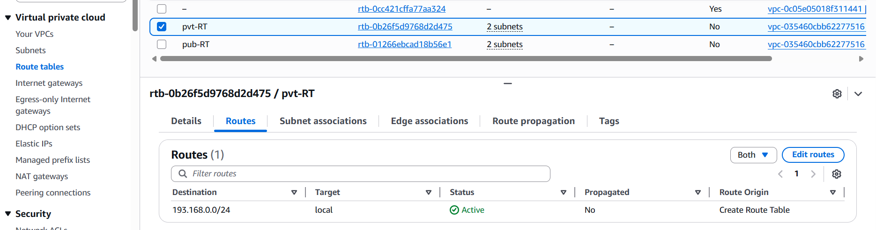
Step 7: In Edit Routes select Destination, Target and save changes.
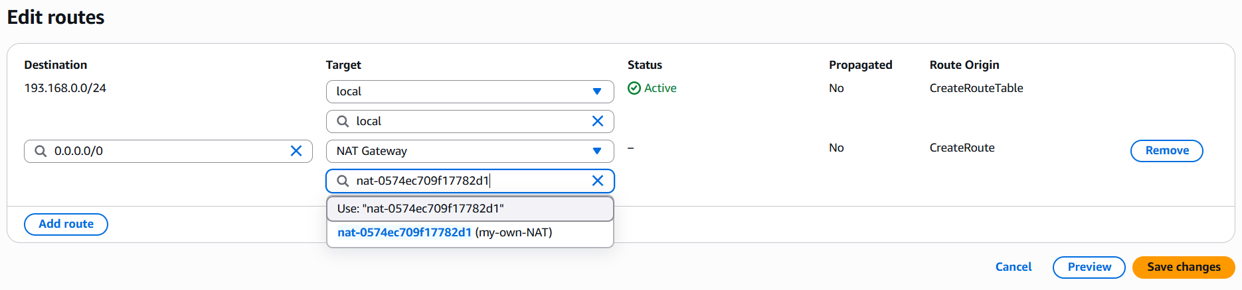
Step 8: Now try ping URL in private instance, it will connect to the host.
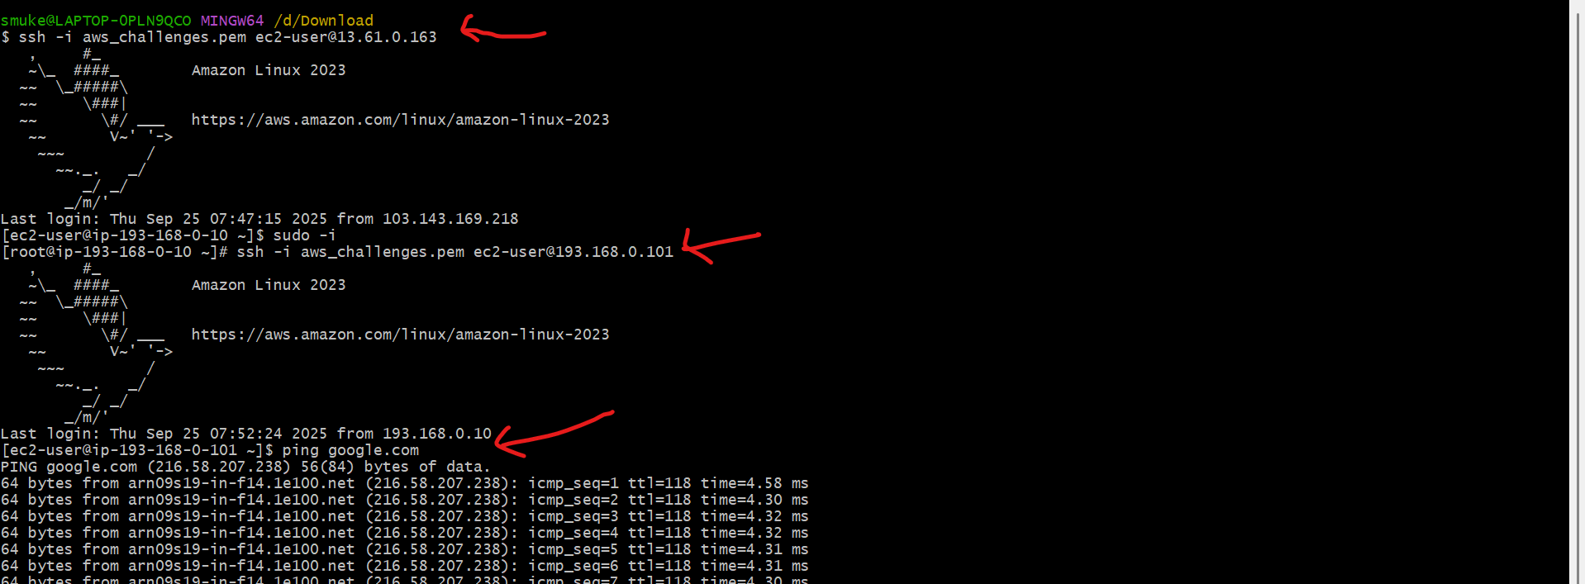

- Install Apache Tomcat in private EC2 and deploy a sample app.
Step 1: Connect to private instance using Jump/Bastian server and goto opt/ directory.
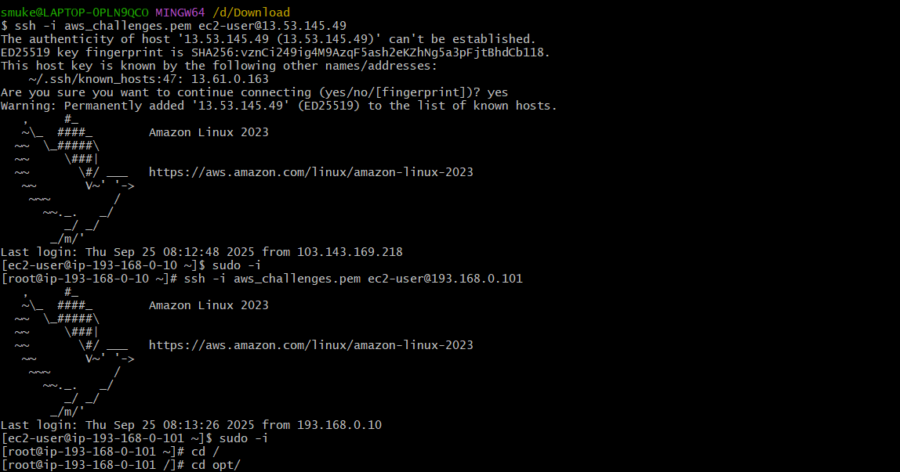
Step 2: Install java using sudo yum install java command.
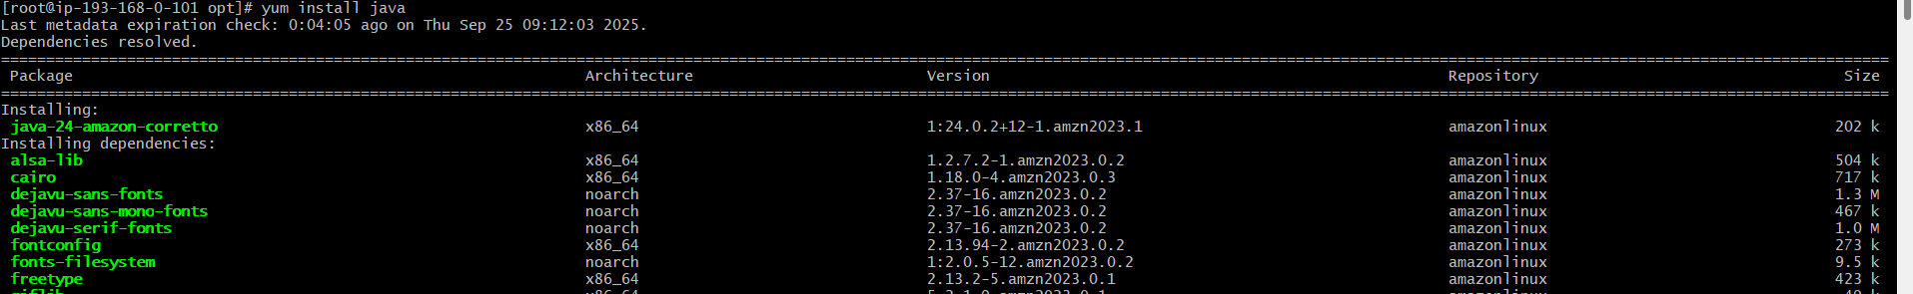
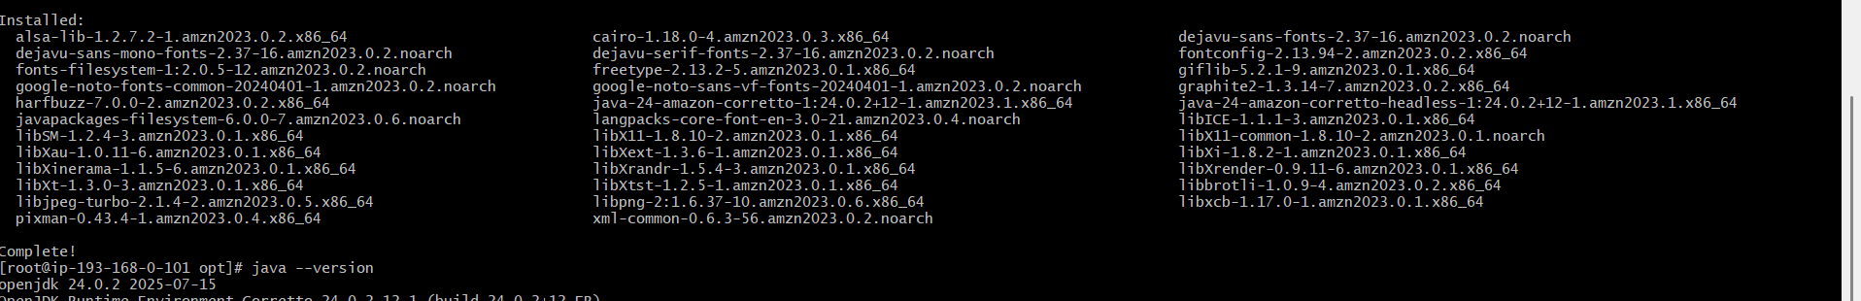
Step 3: Download apache tomcat using wget tomcat_URL and extract it.
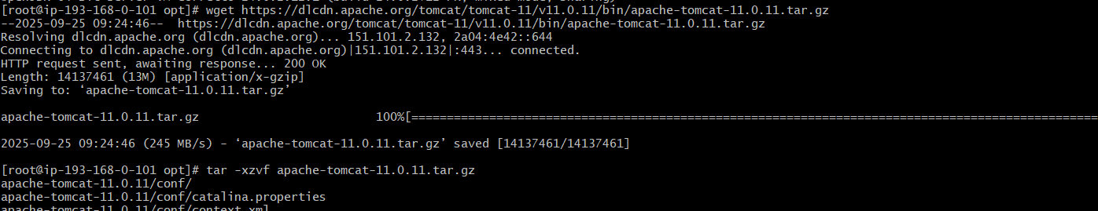
Step 4: Start tomcat using ./startup.sh and run curl http://private_ip:8080
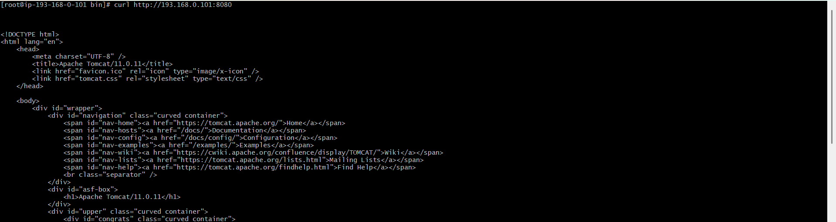

- Configure VPC flow logs and store the logs in S3 and CloudWatch.
S3
Step 1: Login to your AWS console and select S3Create BucketEnter DetailsCreate bucket and copy ARN.
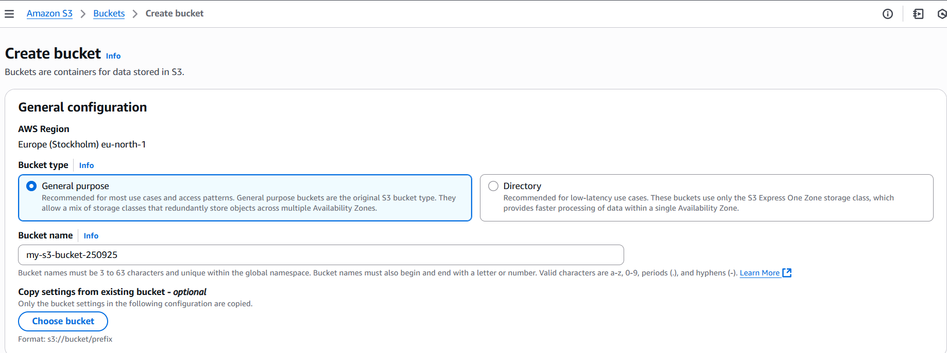
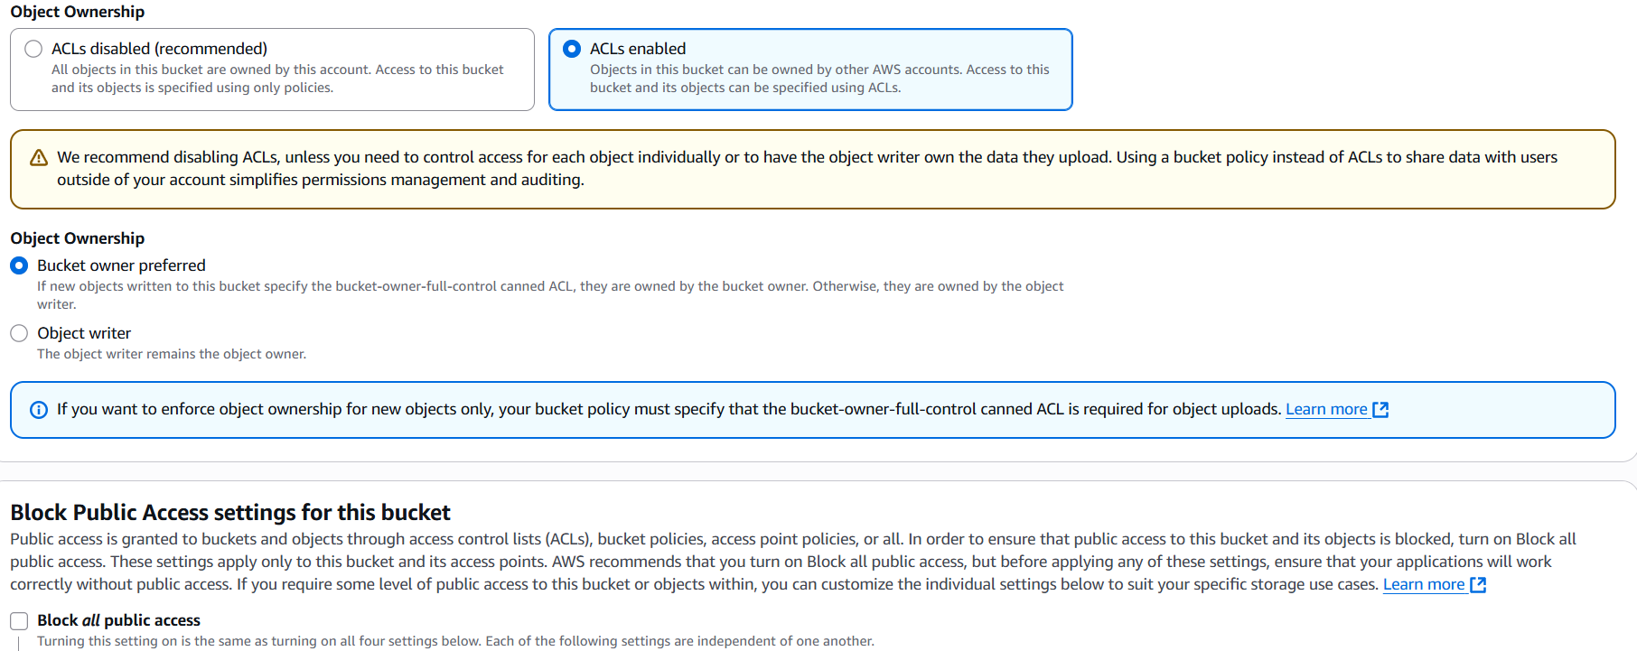
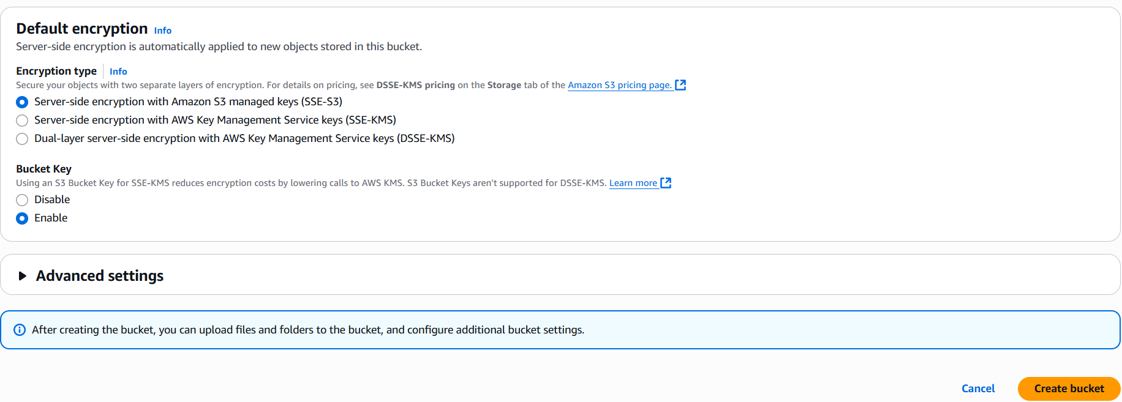
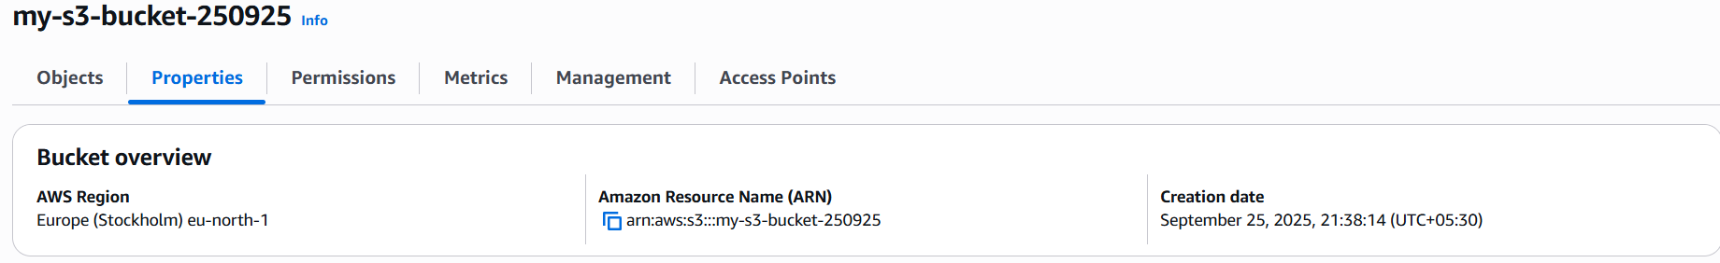

Step 2: Select VPCyour VPCFlow LogsCreate flow logEnter DetailsCreate flow log.
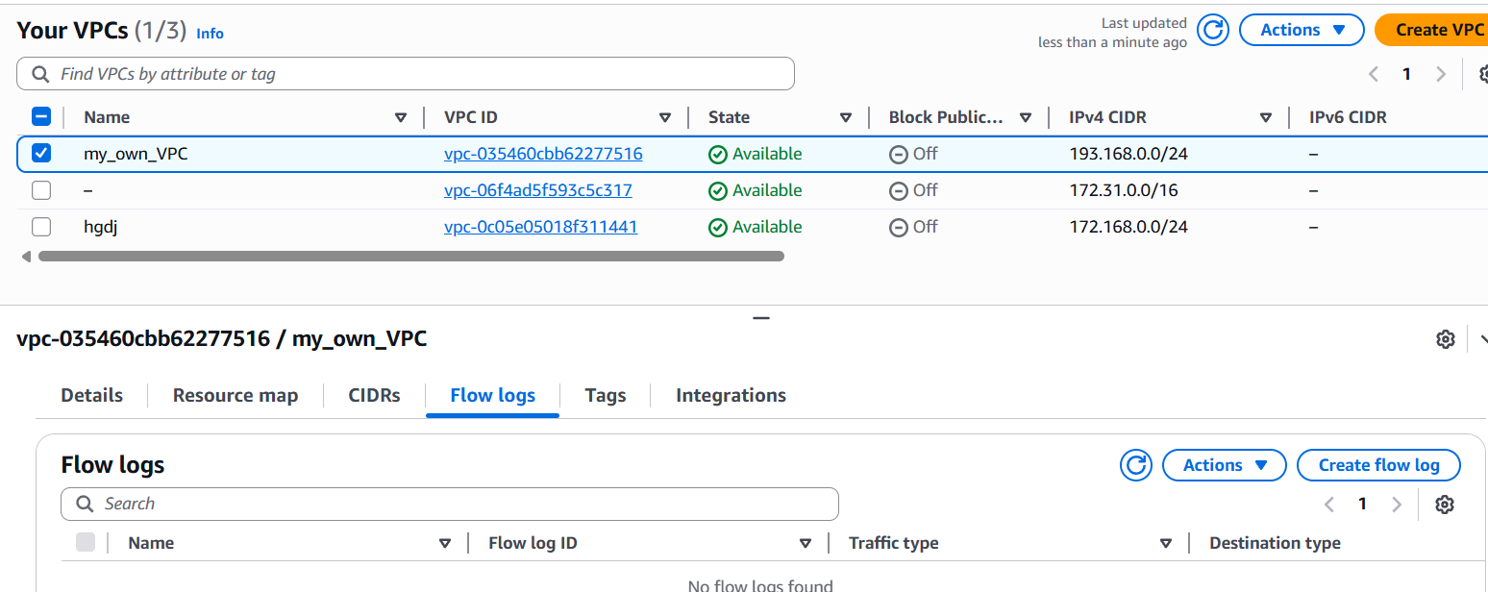
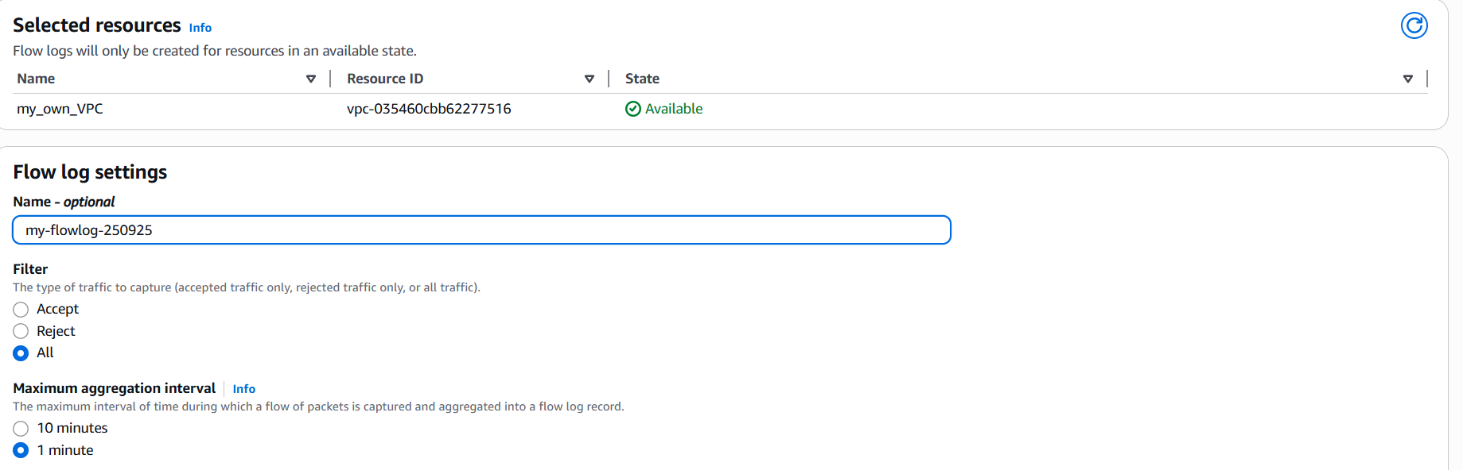
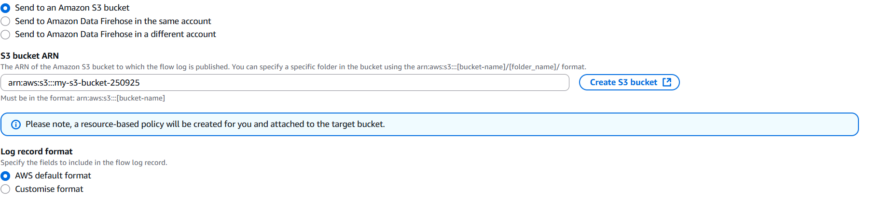
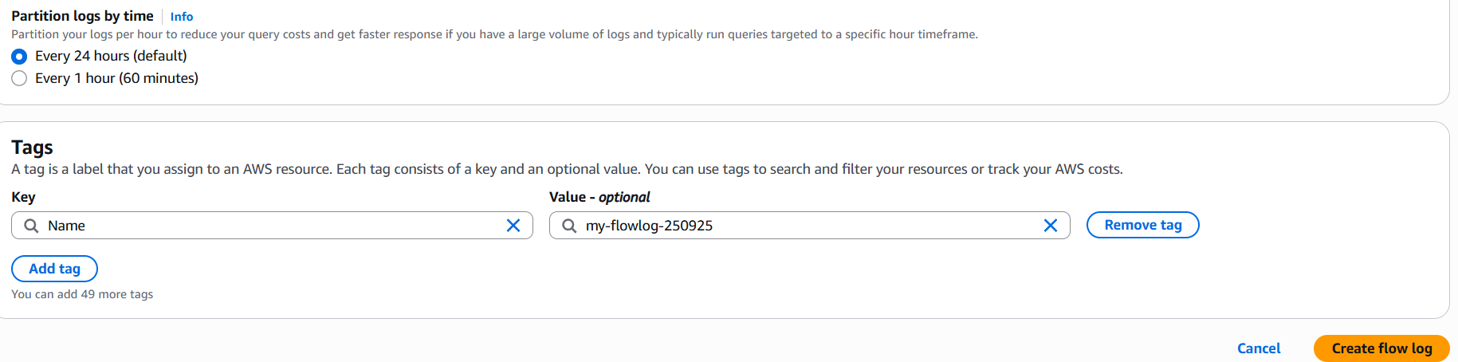
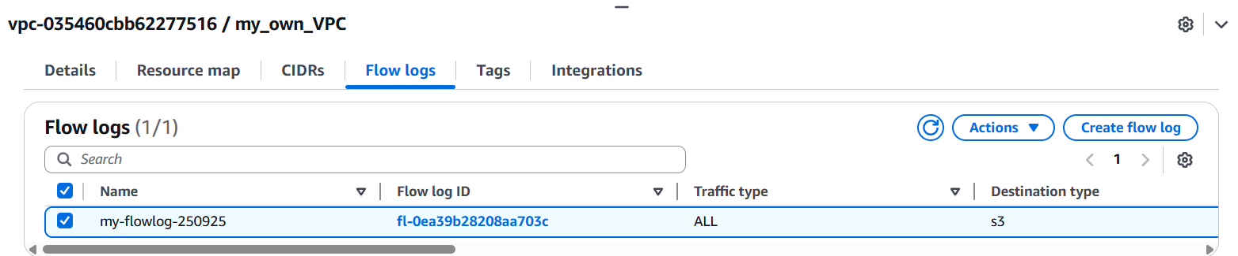
Step 3: Check S3 Bucket for flow logs download and extract it.
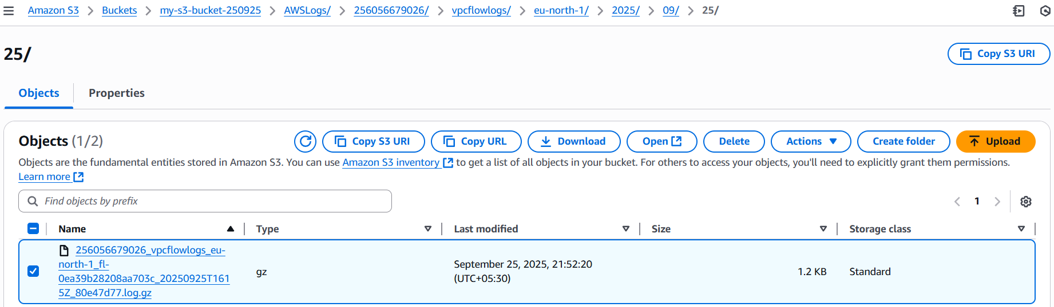
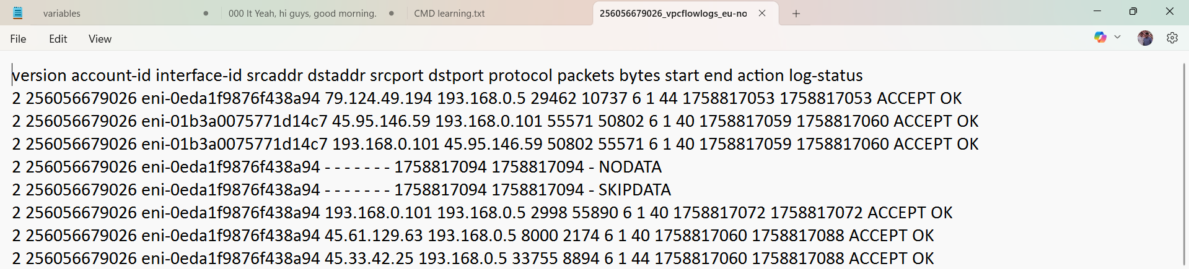

CloudWatch
Step 1: Login to your AWS console and select CloudWatchLog groupEnter DetailsCreate.
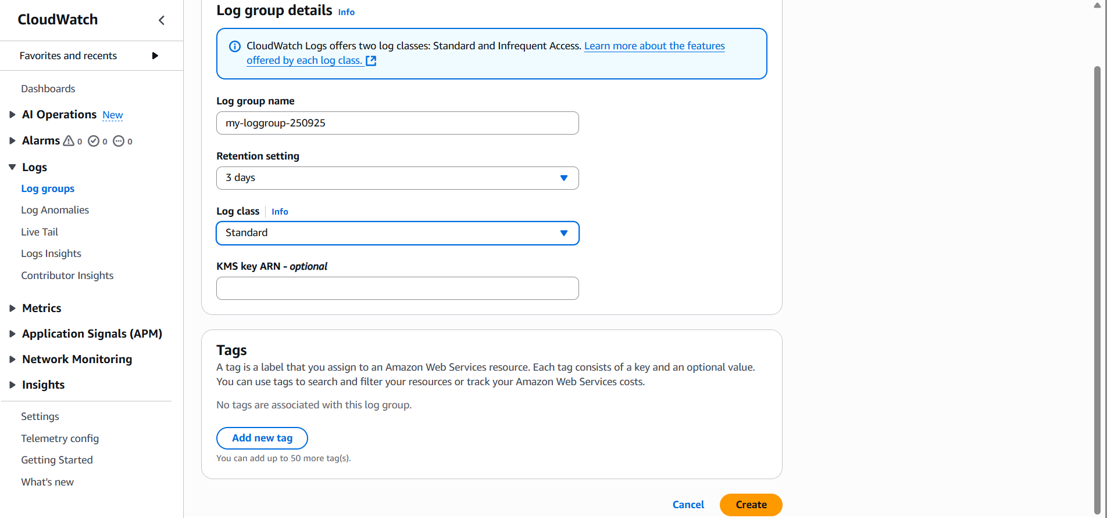
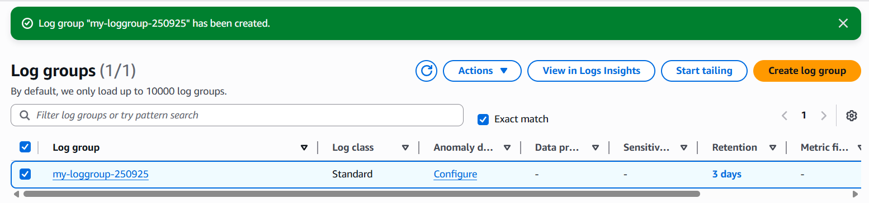

Step 2: Select VPCyour VPCFlow LogsCreate flow logEnter DetailsCreate flow log.
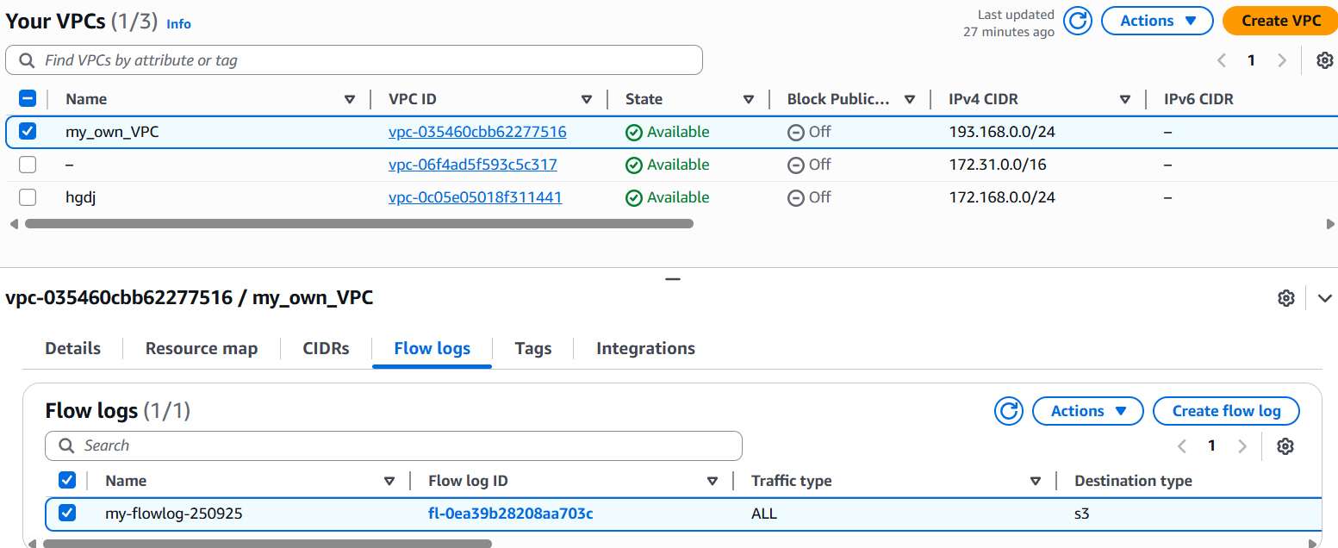
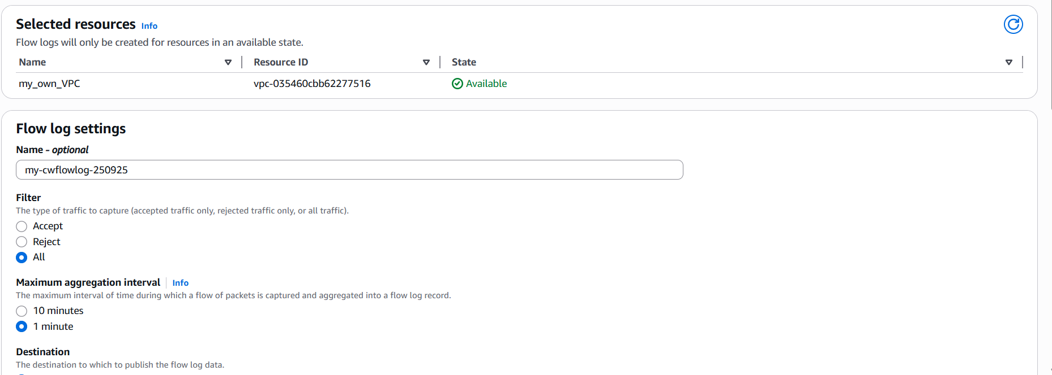
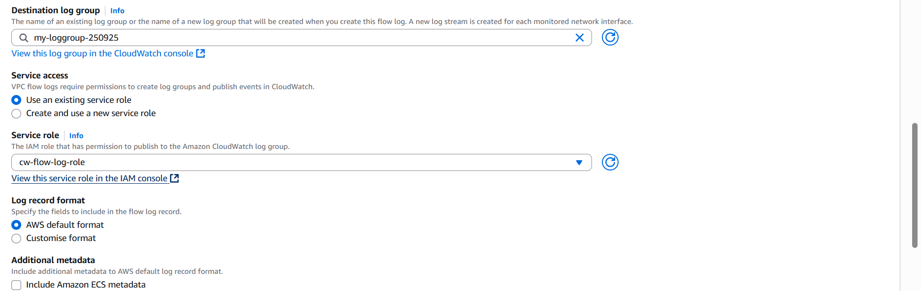
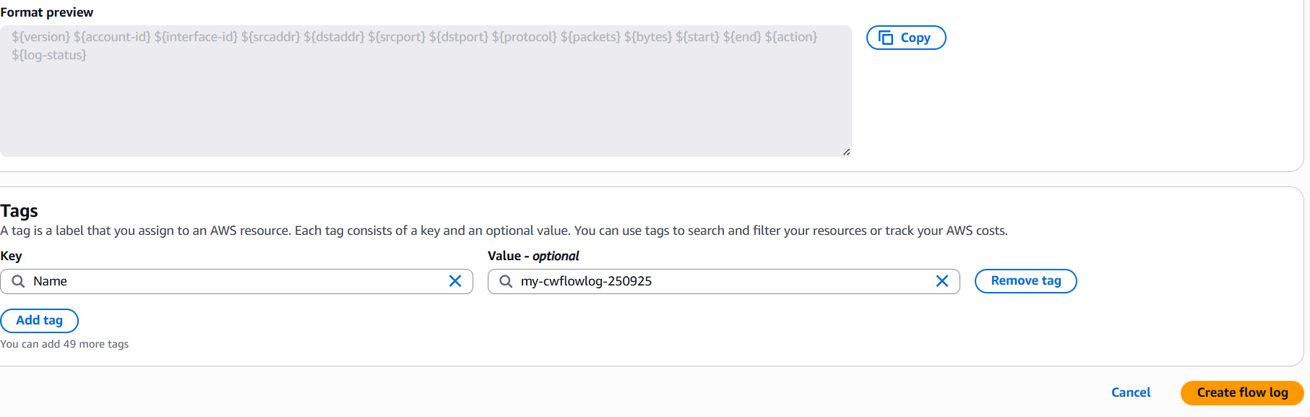
Step 3: Goto CloudWatch and double click on logstream to open log.
